SQL constraints

Are used to define rules for the data in an entity. They limit values for attributes which ensures the integrity of a database and the reliability of the data. If there is any violation between the constraint and the data, the data cannot be inserted. Constraints can be attribute or table level

NOT NULL

Definition: to guarantee that an attribute does not accept NULL values

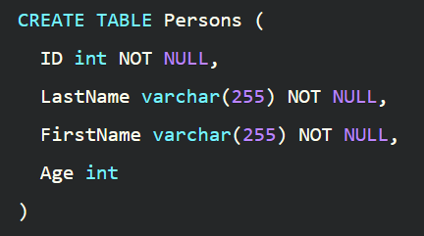

This example demonstrates how you can ensure that the ID, Lastname, and Firstname attributes will NOT accept NULL values when the Persons table is created

CHECK

Definition: to restrict the possible values of an attribute

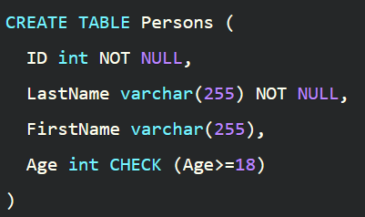

This example shows how you create a CHECK constraint on the Age attribute when the Persons table is created. The CHECK constraint ensures that the age of a person must be 18 or older

UNIQUE

Definition: to guarantee that all values of an attribute are different

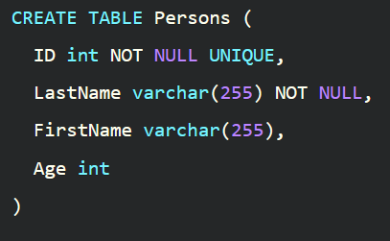

The above query shows how you create a UNIQUE constraint on the ID attribute when the Persons table is created

PRIMARY KEY

Definition: to define an attribute or a set of attributes that uniquely identifies a record in a table

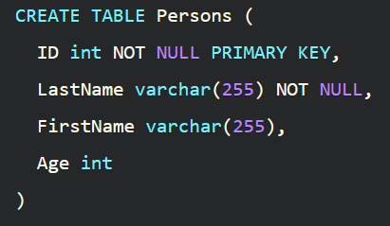

Iin the above query, you create a PRIMARY KEY on the ID attributes when the Persons table is created

FOREIGN KEY

Definition: to define an attribute or a set of attributes that identifies a record from another table

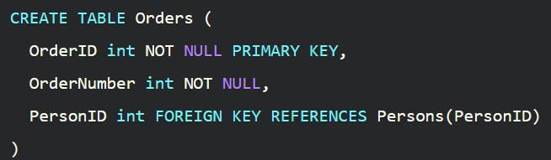

In the above query, you can see how to create a FOREIGN KEY on the PersonID attribute when the Orders table is created